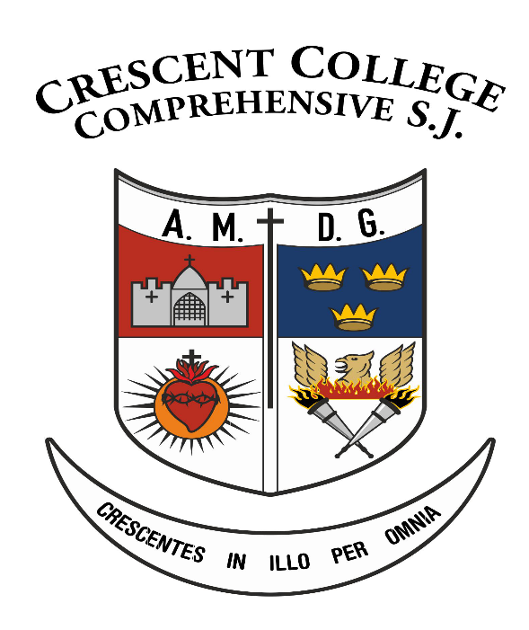

Substance Abuse Policy

Table of Contents

1. Introduction 3
2. Relationship to Mission Statement 3
3. Rationale for this Policy 3
4. Scope of Policy 4
5. Aims and Objectives of the Policy 4
6. Substance Abuse Education: 5
6.1 Students 5
6.2 Parent(s)/Guardian(s) 5
6.3 Teachers 6
7. Procedures for Dealing with Substance Abuse Issues 6
7.1 Examples of Substance Abuse Incidents include: 6
7.2 Exceptions 6
8. Addressing and Managing Substance Abuse Incident 7
9. Disciplinary Procedures 7
10. Dissemination and Review of Policy 7
11. Approval 8
Appendix 9
Appendix I 9
1st year SPHE 9
2nd Year SPHE 9
3rd Year SPHE 9

1. Introduction
The central objective of Crescent College Comprehensives SJ (CCC SJ) substance abuse policy is the welfare, care, protection and education of all members of the school population at CCC SJ. It also equips the College to deal with issues relating to substance abuse in a planned and considered way and in accordance with their statutory responsibilities.
For the purpose of this policy the term ‘substance’ is defined as; “any substance which changes the way the body functions, mentally, physically or emotionally.” The definition includes not only the whole range of illegal substances available in modern society, but also legally available products such as over-the-counter and prescription medicines, drug paraphernalia, tobacco and nicotine products, e-cigarettes and related products, alcohol and solvents. The list is not exhaustive.

2. Relationship to Mission Statement
Crescent College Comprehensive SJ incorporates the Characteristics of Jesuit Education, seeks to develop a community of learning and academic excellence comprising teachers and parent(s)/guardian(s) collaborating to fulfil the development of each individual pupil. This will involve teachers, parent(s)/guardian(s) and pupils working together to identify and develop an openness to religion, moral, social, intellectual, cultural, and physical experience and to the word of God in all its dimensions. Each individual’s talents will be developed to the level of their personal potential for the benefit of community and humanity.
The Substance Abuse Policy derives from the Mission Statement and is directly linked to its aims, in particular helping all students to achieve their full potential in their development. This philosophy is central to this policy document so that the aims of the mission statement can be fulfilled.
This school also acknowledges the role it plays in drugs/substance education both in terms of prevention and offering support to those who use drugs/substances.

3. Rationale for this Policy
- The Department of Education recommends that the main objectives of a school policy should be:
  - The welfare, care and protection of every young person in line with the Education Act (1998) and the Education Welfare Act (2000)
  - In addition, the Education Act (1998) provides that schools should promote the social and personal development of students and provide health education for them

- The National Drugs Strategy, ‘Building on Experience’, ‘Reducing Harm, Supporting Recovery’, is now Government policy (Circular 18/02) requires every school to have a substance use policy in place.

  - “The world in which we live presents young people with many challenges which affect their health and well-being. Exposure to alcohol, tobacco and drugs is part of this reality. Schools need to reflect upon how they might provide for the needs of their student cohort and respond appropriately to what are sometimes sensitive and emotive issues” (Guidelines, P1).

4. Scope of Policy
This policy applies:
- To the whole school community during school time
- During school related activities
- To all who use the school facilities or who are employed to work on or with the school facilities within the school boundaries

5. Aims and Objectives of the Policy
CCC S.J. has a role in the process of enabling individuals to increase control over and improve their health. The school is committed to addressing the needs of the whole school in relation to substances. We believe that teachers, parent(s)/guardian(s), the Board of Management, students and other relevant personnel need to work together and that cooperation is essential to the acceptance and implementation of this policy. In addition, the school does not accept the possession, use or supply of any substance in the school, on school trips or activities by any member of the school community. The school endeavours to promote the wellbeing of individuals by:
- Providing a policy with fair and transparent procedures for dealing with substance use issues and complying with our statutory requirements
- Facilitating a safe and healthy environment
- Promoting positive health behaviours through:
- Increasing knowledge about health
- Promoting the self-esteem of individuals
- Working with parent(s)/guardian(s), students, teachers and outside agencies
- Supporting students and their families who are affected by substance use

6. Substance Abuse Education:

6.1 Students
Education around substance use is best carried out within the overall context of a healthy living programme – Social Personal Health Education (SPHE). SPHE is a core curriculum programme within the school and is compulsory for all Junior Cycle students who receive a short course which includes three Units of Learning on ‘Substance Use’ (see Appendix I).

The SPHE programme also makes use of peer education approaches. Substance abuse/use talks from peers or older students can have a greater impact and credibility.
Where possible the use of an outside visitor/speaker to enhance the work done in class will be conducted in 2nd year of the SPHE programme.

6.2 Parent(s)/Guardian(s)
Parent(s)/Guardian(s) are obliged to understand and accept the full extent of their responsibilities in relation to education in and prevention of substance abuse. In this regard, parent(s)/guardian(s) shall:

- Inform the school of any professionally prescribed medication and all other medical or relevant information concerning their child
- Attend the Substance Awareness talks when offered by the school to parent(s)/guardian(s) in conjunction with those delivered to their child
- Educate their child about the nature, danger and consequence of substance abuse
- Satisfy themselves that their child is aware of, understands and accepts the Code of Behaviour required of students, and in the context of this policy the schools’ prohibition of any substances
- Inform the school Principal if they suspect and/or are concerned about their child in relation to any actual or potential incident of substance abuse
- Attend all meetings organised by the school in relation to any actual or potential substance abuse incident involving their child
- Understand that the Board of Management reserves the right to request a medical report verifying that their child is drug free, before allowing them to return to the school
- Cooperate fully with the school authorities in the event of their child being involved in an incident of substance abuse

6.3 Teachers
Teachers involved in SPHE are given the opportunity to avail of training in group facilitation skills and personal development where available. School management will respond positively whenever possible to any requests made by teachers for training in this area.

7. Procedures for Dealing with Substance Abuse Issues
These procedures are in conjunction with the Code of Behaviour Policy, Health and Safety Policy and the Accident and Emergency Procedures.

7.1 Examples of Substance Abuse Incidents include:
- The use, or suspected use, of alcohol, tobacco and vaping (e-cigarettes), illegal drugs or any mind/mood altering substances on the premises or during a school-related activity
- Emergencies where the person may be unconscious
- Intoxication/Unusual Behaviour
- Suspicion of substance use, possession or dealing (supplying to others)
  - Suspicion includes two or more persons in a toilet cubicle at one time
  - A group of students or an individual student behaving out of character (i.e. changes in body function, mentally, physically or emotionally)
- Possession of substances or associated paraphernalia on the school premises or on a school related activity
- Disclosure of a person involved in substance abuse
- Substance/drug paraphernalia found on school property

The above list is not exhaustive.

7.2 Exceptions
- Medication professionally prescribed for specific conditions for students (as evidenced by the schools’ (apostrophe needed) written records)

8. Addressing and Managing Substance Abuse Incident
- When an incident of substance abuse occurs, it is deemed to be as a serious incident. The school will take all appropriate and necessary steps to fully investigate any substance abuse incident
- The school reserves the right to suspend or remove temporarily from the school any student involved in a suspected substance abuse incident pending a further and complete investigation of the incident
- An incident of substance abuse may give rise to personal, pastoral, disciplinary, legal and other considerations. Whereas pastoral support is offered to all students affected by such an incident, the school will at all times discharge its moral legal obligations to report matters to relevant authorities, as appropriate and necessary
- Whereas information concerning an incident of substance abuse is treated as confidential, the school does not and cannot guarantee absolute confidentiality or non-disclosure of the information related thereto. Information is communicated on a need to know basis, including, where necessary to the relevant authorities
- Where a student presents with a substance abuse problem a referral to the appropriate support services will be made

9. Disciplinary Procedures
In the event of an incident of substance abuse, disciplinary procedures in accordance with the schools’ rules for breaches of the Code of Behaviour will be implemented.
Students who engage in Substance Abuse Incidents and who fail to respond, as required by the school, may face permanent expulsion.

10. Dissemination and Review of Policy
The school Policy on Substance Abuse shall be distributed to all members of the school Community. It shall be published on the school Website and Parent(s)/Guardian(s) of all pupils will be made aware of where to access School policies on the school website.
The College shall monitor and review this Policy on a periodic basis and shall seek to ensure that the best practice in relation to the prevention and management of a substance abuse is observed.

11. Approval
This policy was approved by the Board of Management of Crescent College Comprehensive SJ.
On __________________________ (Date)

______________________________ ______________________________
Chairperson, Board of Management Secretary, Board of Management
Crescent College Comprehensive SJ Crescent College Comprehensive SJ

12. Appendix

Appendix I

1st year SPHE
- Critique the impact of the media, advertising and other influences on one’s decisions about health and wellbeing.
- Describe what promotes a sense of belonging in school, at home and in the wider community and their own role in creating an inclusive environment.
- Distinguish between appropriate care giving and receiving.
- Demonstrate the personal and social skills to address pressure to smoke, to drink alcohol and/or use other substances.
- Reflect on the personal, social and legal consequences of their own or others drug use.

2nd Year SPHE
- Demonstrate the personal and social skills to address pressure to smoke, to drink alcohol and/or use other substances.
- Reflect on the personal, social and legal consequences of their own or others drug use.
- Explain the significance of substance use for one’s mental health.

3rd Year SPHE
- Demonstrate the personal and social skills to address pressure to smoke, to drink alcohol and/or use other substances.
- Reflect on the personal, social and legal consequences of their own or others drug use.
- Critique information and supports available for young people in relation to substance use.
- Explain the significance of substance use for one’s mental health.

